Phase 4: Process Automation (Admin)
In this phase, the focus was on automating business processes without requiring Apex code. The main requirement in our project was to automatically adjust inventory quantities whenever a new Partner Order was placed.

4.1 Record-Triggered Flow for Inventory Update
Objective:
Whenever a new Partner Order record is created, the system should automatically subtract the ordered quantity from the available inventory of the selected product.
Steps Implemented:
- Navigate to Flows
  - Go to Setup → Quick Find Box → search for Flows → click New Flow.
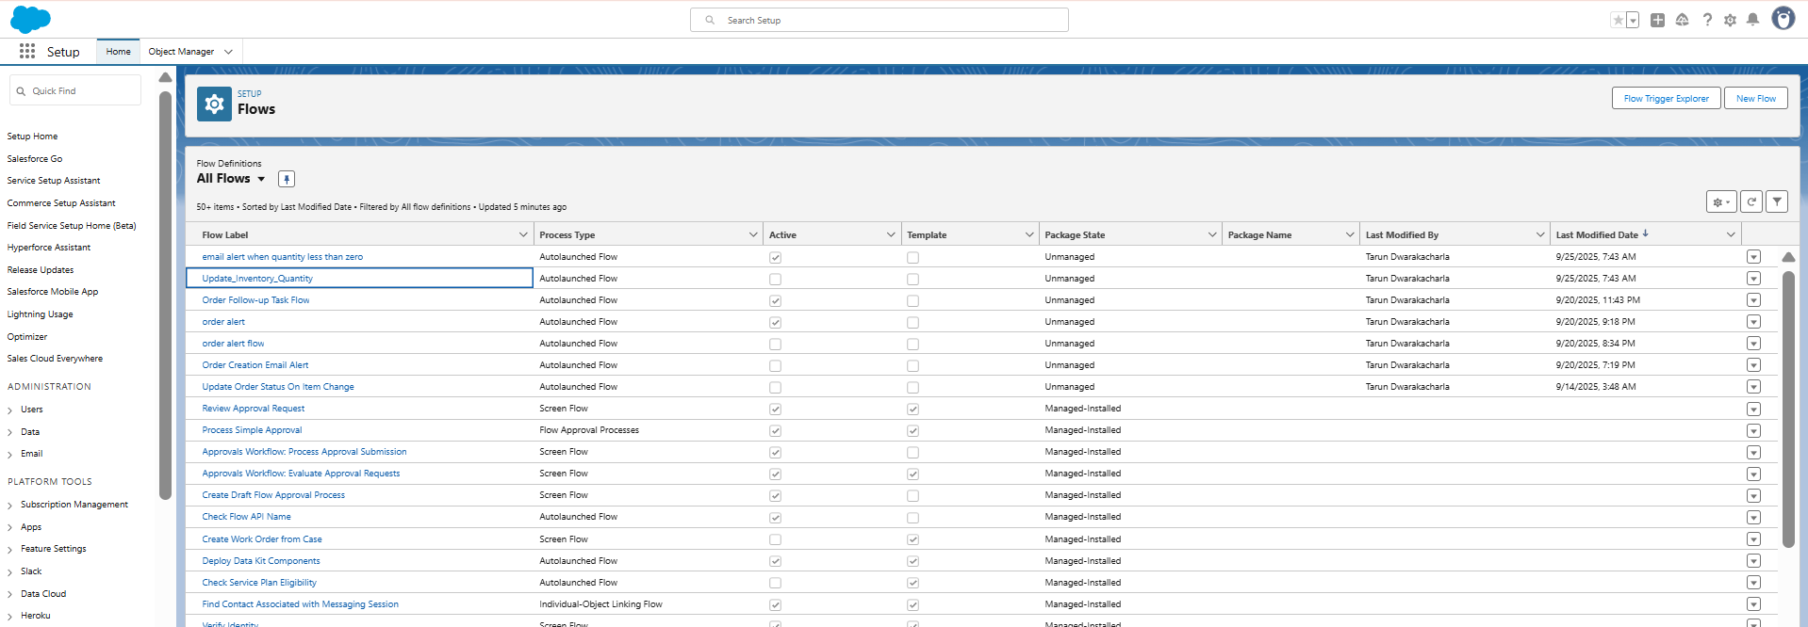
- Choose Flow Type
  - Select Record-Triggered Flow.
  - Object: PartnerOrder__c
  - Trigger: When a record is created.
  - Condition: None (runs for every new Partner Order).
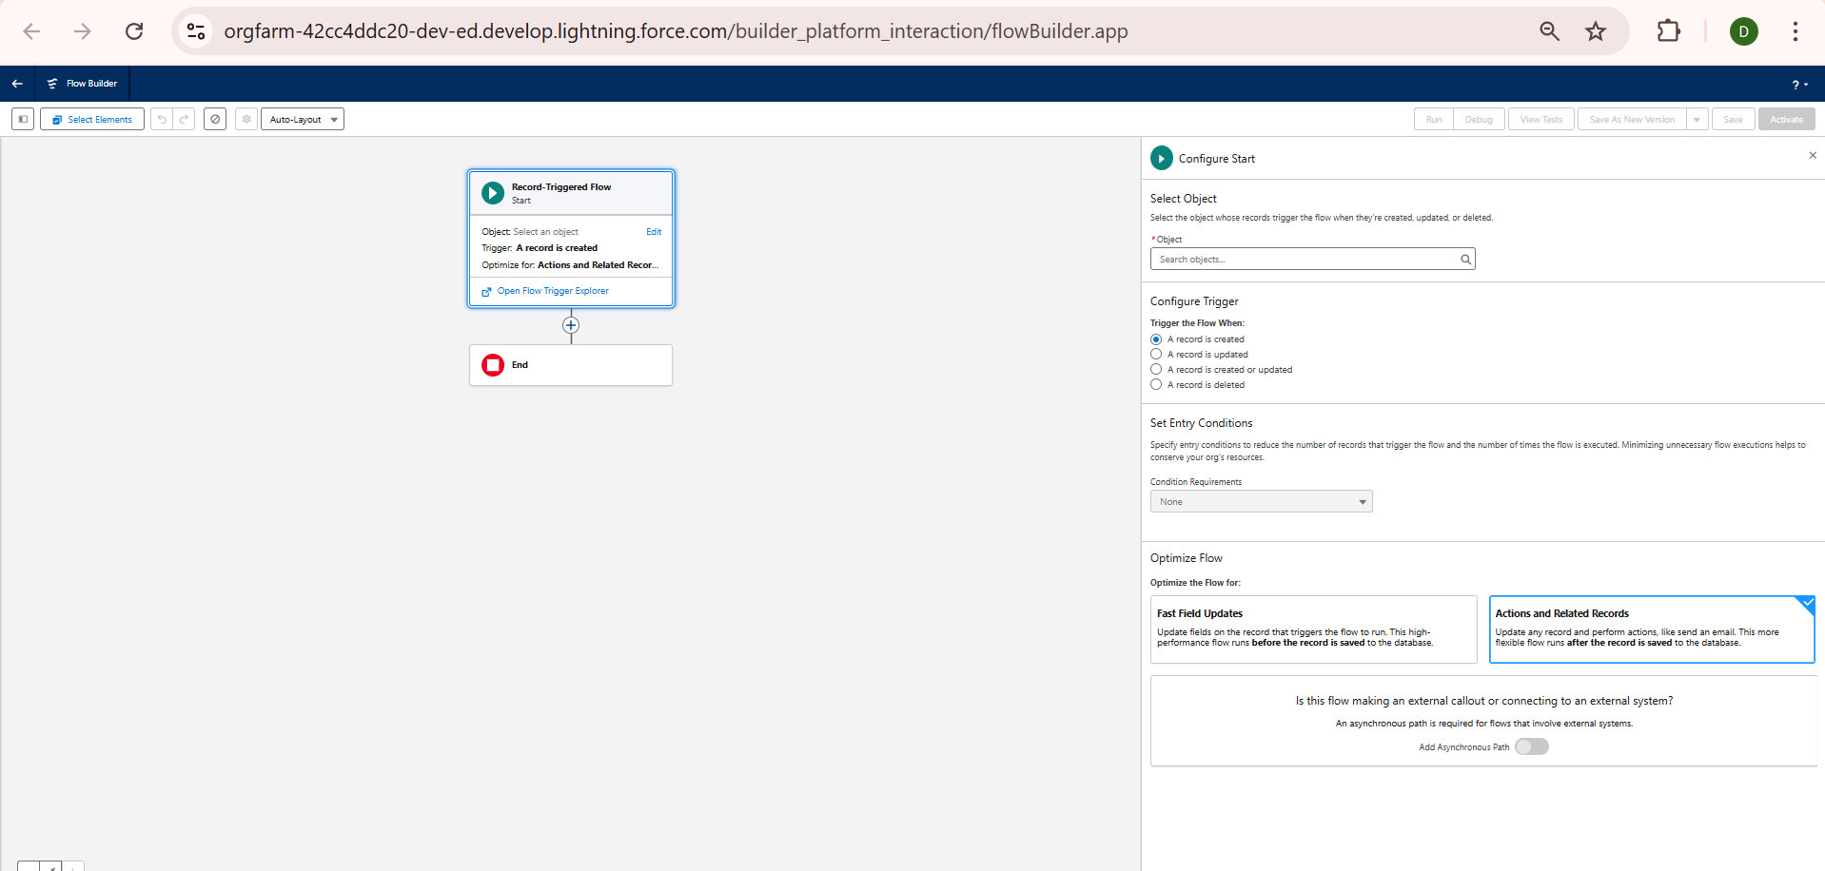
- Get Related Inventory Record
  - Add a Get Records element.
  - Object: Inventory__c
  - Condition: Product__c = {!$Record.Product__c}
  - Store the first record found.
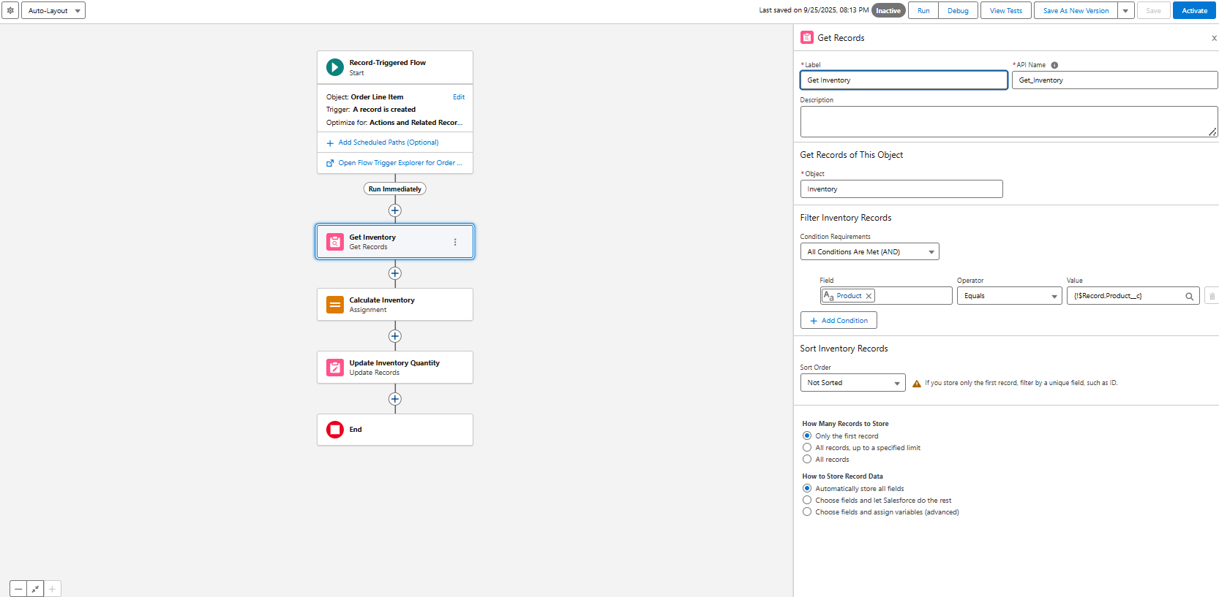
- Update Inventory Quantity
  - Add an Update Records element.
  - Record to Update: Inventory record from Get Records.
  - Field:
    - QuantityAvailable__c = {!Get_Inventory.QuantityAvailable__c} - {!$Record.Quantity__c}
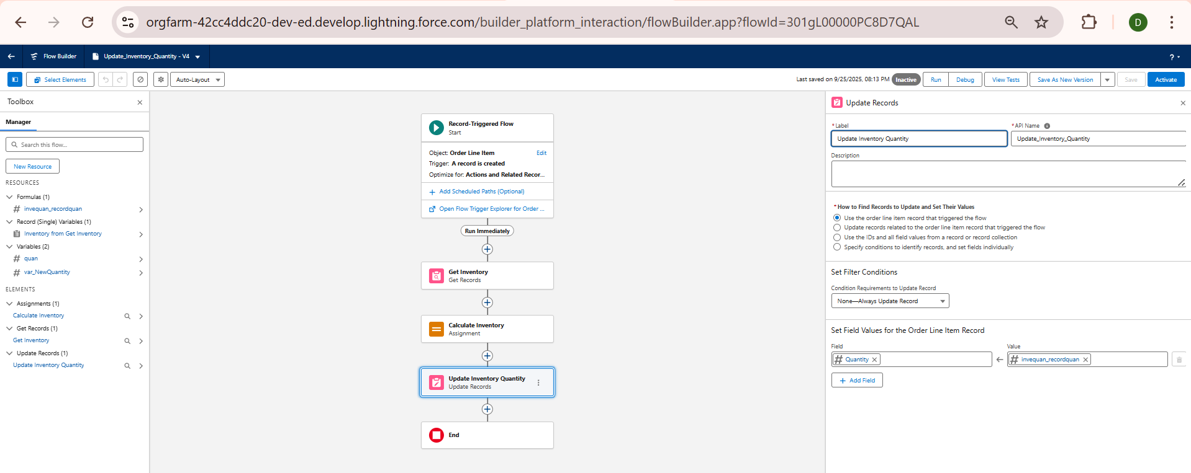
- Save and Activate Flow
  - Save the flow with the name: Update Inventory Quantity on Partner Order.
  - Activate it.

4.2 Testing the Flow
- Go to the Partner Order Page.
- Create a new Partner Order by selecting a Product and entering a Quantity.
- After submitting the order:
  - Navigate to the related Inventory__c record.
  - Confirm that the QuantityAvailable__c has been reduced by the ordered amount.
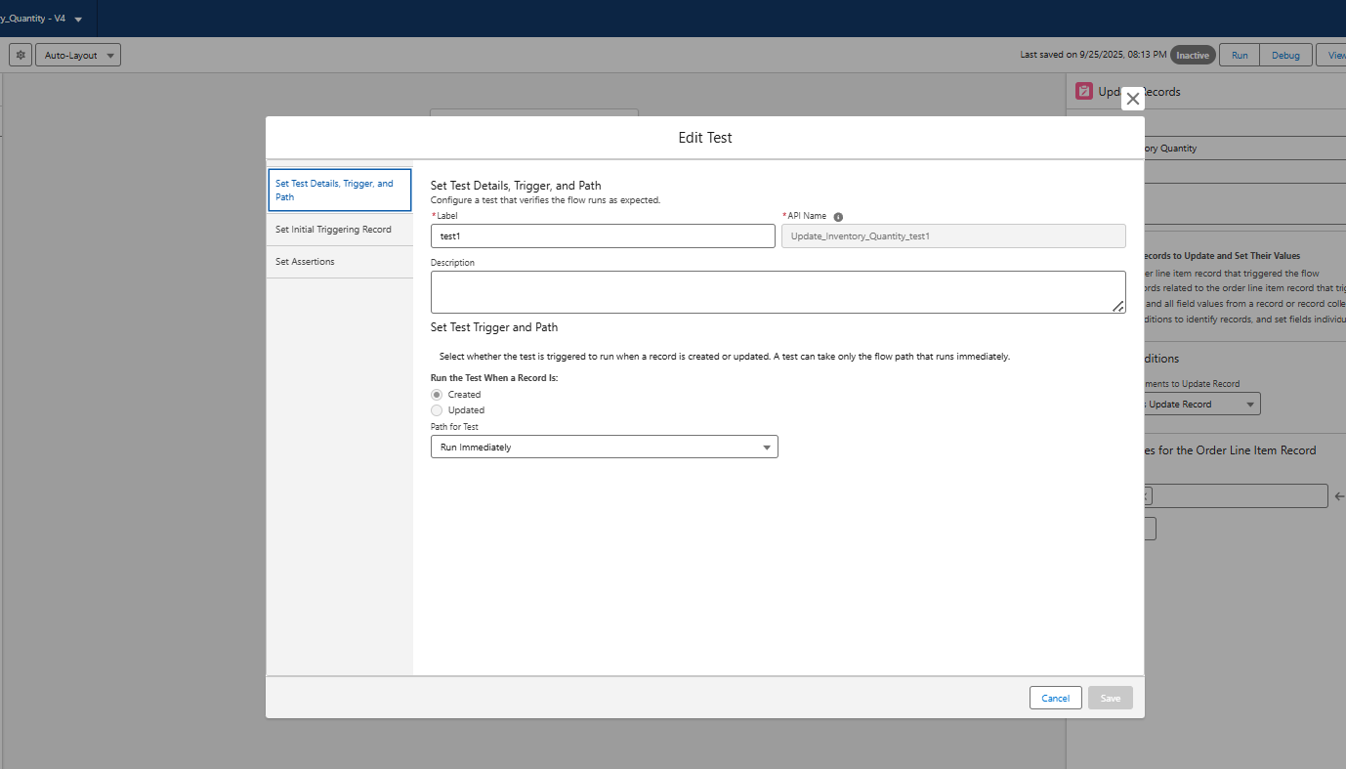
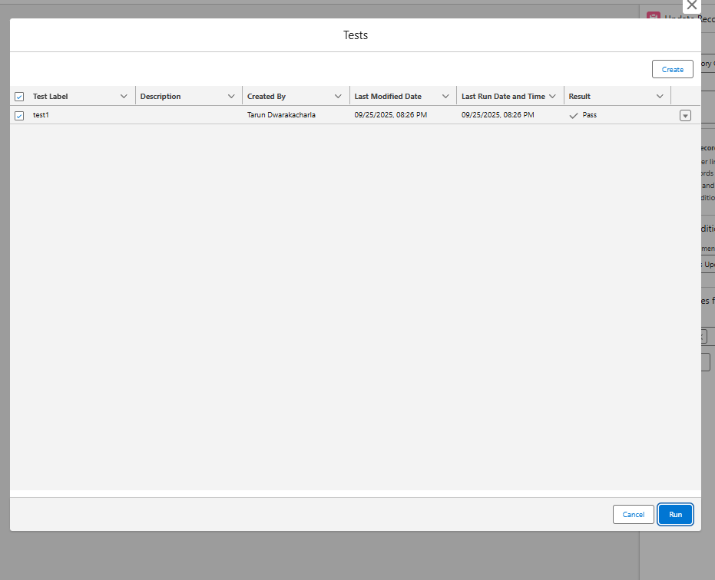

Achieved Outcome
- Inventory is now automatically updated whenever a Partner Order is created.
- No manual adjustments are required, reducing the chances of stock mismatches.

2. Validation Rule on Partner Order Quantity
Objective: Prevent users from entering invalid order quantities (e.g., negative or zero).
Steps:
- Go to Setup → Object Manager → PartnerOrder__c → Validation Rules.
- Click New Rule.
- Rule Name: Validate_Quantity
- Formula:
- Quantity__c <= 0
- Error Message: "Quantity must be greater than zero."
- Error Location: Field → Quantity__c.
- Save & Activate.
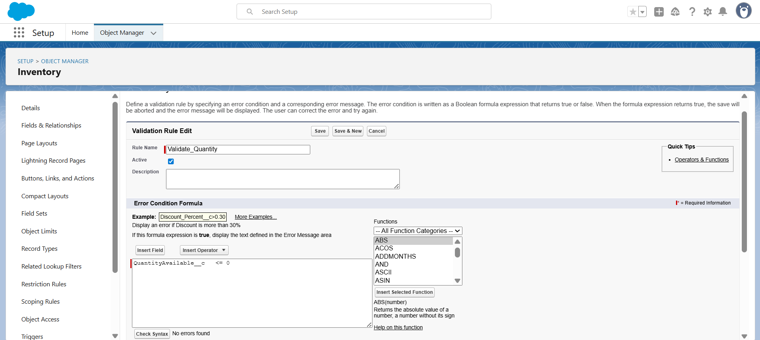
✅ Result: Users cannot save orders with zero or negative quantity.

🔹 2. Email Alert on Low Inventory
Objective: Notify an Admin when Inventory goes below a certain threshold (say 10 units).
Steps:
- Go to Setup → Flow.
- Create a Record-Triggered Flow on Inventory__c.
- Trigger: When a record is updated.
- Condition:
  - QuantityAvailable__c < 10.
- Action: Add Send Email.
  - Recipient: Admin Email (you can hardcode your email ID for testing).
  - Subject: "Low Inventory Alert"
  - Body: "The product {!$Record.Product__c} has low stock: {!$Record.QuantityAvailable__c} units left."
- Save & Activate.
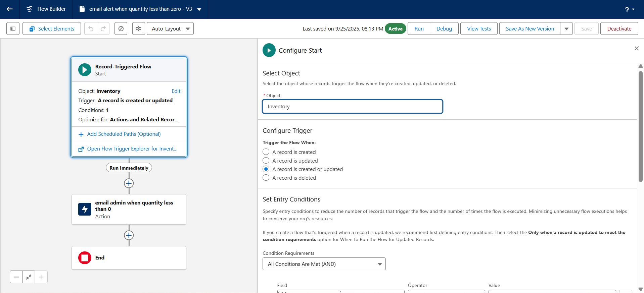

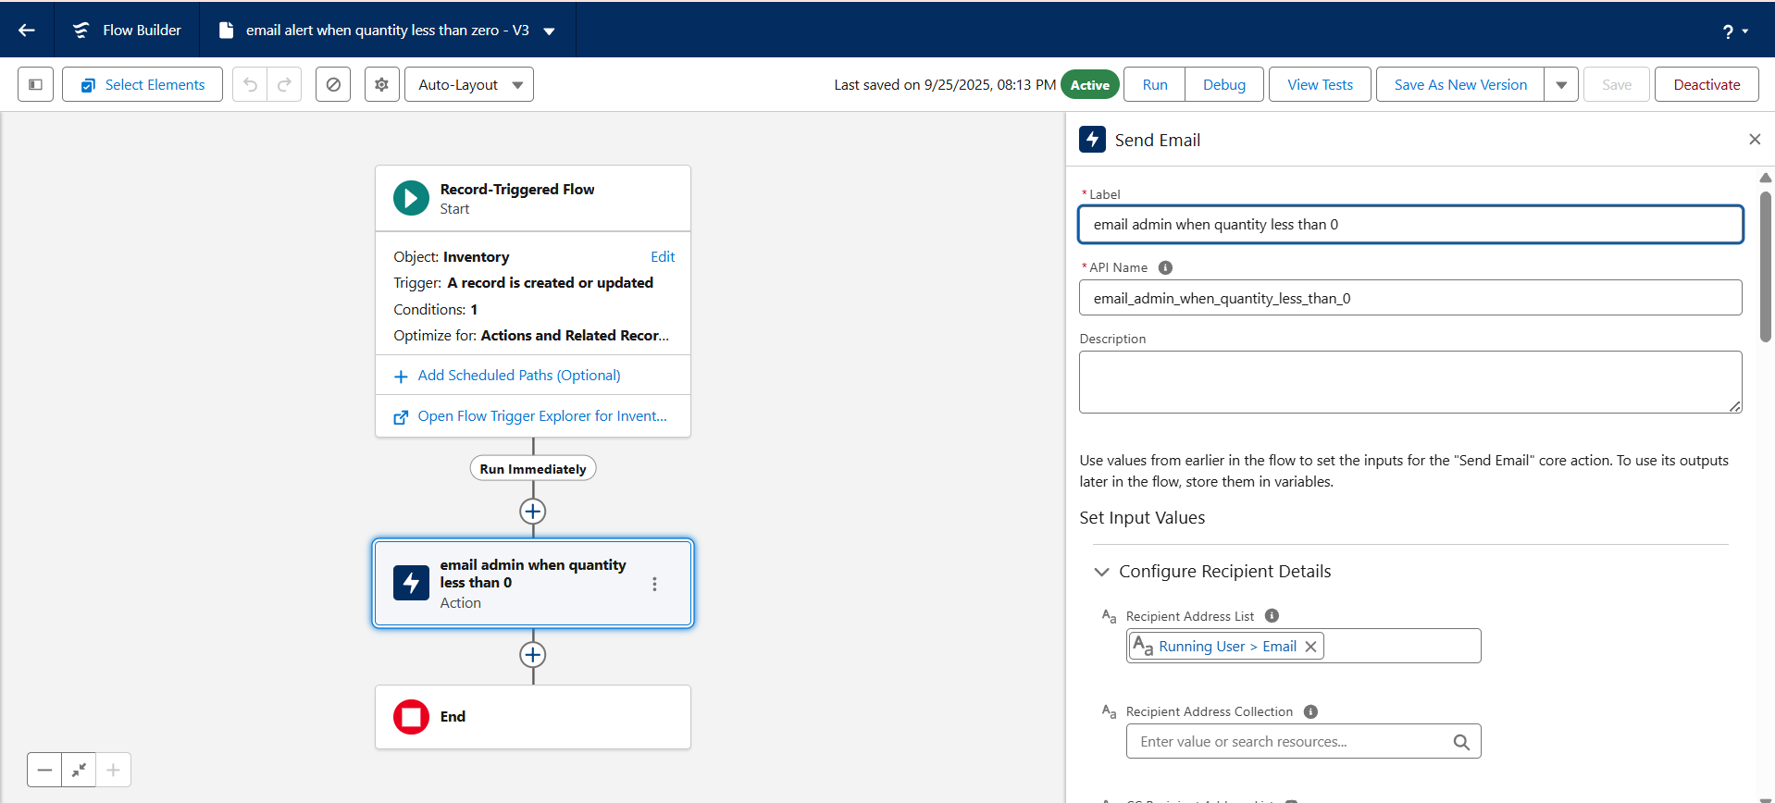

Testing the flow:
